2006-11-21 [1017] Second Attempt at Index of Refraction Map

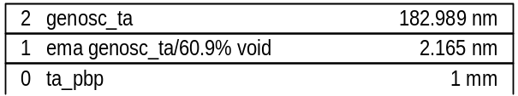

MSE=21.61
thick.2 182.989±0.204
thick.1 2.165±0.136
ema2.1 60.9±2.36
br1.2 0.60878±0.0109
en1.2 4.8778±0.0114
amp1.2 2.6154±0.0531
polemag.2 112.46±0.719
e1offset.2 1.6276±0.0102

